**Family Connect and Support Common Assessment Tool**

Practitioner joint-assessment template

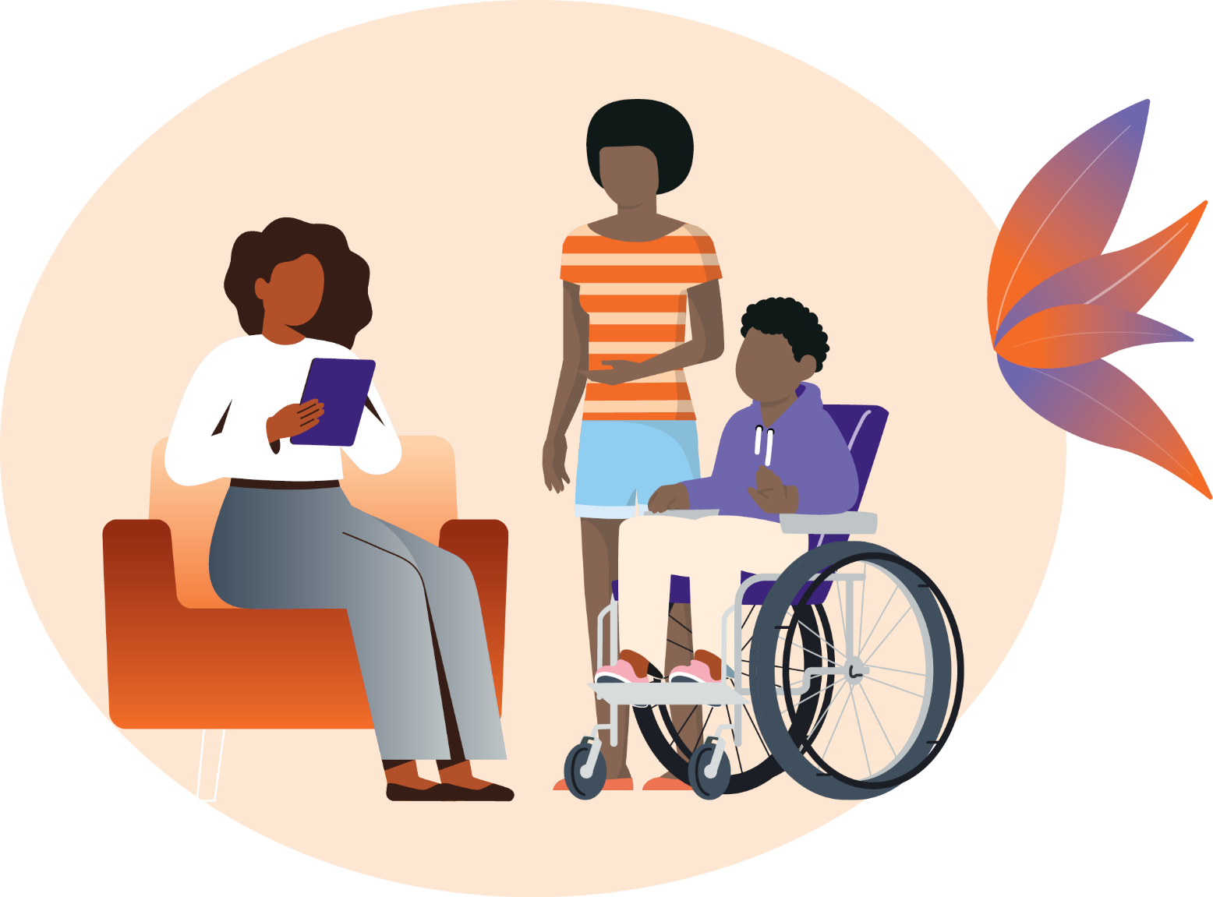

|  |  |
| --- | --- |
| Key information | Details |
| Name of parent/carer(s) |  |
| Relationship to child / young person |  |
| Contact details (phone/email) |  |

|  |  |
| --- | --- |
| Staff member completing assessment | Details |
| Name |  |
| Date started |  |

# Stage 1: Gathering information

What is the main reason you are seeking support for yourself and/or your family?

In this question we are trying to gain an understanding of the reasons you are seeking support for yourself or your family.

|  |
| --- |
| Comments (consider strengths, concerns and any comments made by family member/s) |
|  |

Are any other services or supports currently involved with your family?

In this question we are trying to identify any services you and your family may already be involved with to understand what support you may already be receiving.

|  |
| --- |
| Comments (consider strengths, concerns and any comments made by family member/s) |
|  |

Details of children

|  |  |  |  |  |  |  |  |  |  |
| --- | --- | --- | --- | --- | --- | --- | --- | --- | --- |
| Name | Age | DOB | Gender | School / Day care | Cultural identity | Relationship to primary carer (client) | Medical diagnosis / Medical issue | Disability | Additional needs |
|  |  |  |  |  |  |  |  |  |  |
|  |  |  |  |  |  |  |  |  |  |
|  |  |  |  |  |  |  |  |  |  |
|  |  |  |  |  |  |  |  |  |  |
|  |  |  |  |  |  |  |  |  |  |

## Domain 1: Social and community

### Culture, religion and identity

In this section we are trying to gain an understanding of your family’s identity, culture, spirituality or religion and any connections you may have to the community. We ask these questions because culture is a strength that should be celebrated, as it can help to keep families strong and connected.

We also would like to know if you have any particular cultural requirements we should know about so that we can try and provide you and your family a culturally safe experience.

|  |  |  |  |  |  |
| --- | --- | --- | --- | --- | --- |
| Culture, religion and identity | Strongly disagree | Disagree | Undecided | Agree | Strongly agree |
| My family and I are connected to our culture |  |  |  |  |  |
| I have a clear sense of what my culture means to me |  |  |  |  |  |
| I feel connected to my community |  |  |  |  |  |

|  |
| --- |
| Comments (consider strengths, concerns and any comments made by family member/s) |
|  |

|  |
| --- |
| Notes for referrals |
|  |

## Domain 2: Family relationships

### Relationships and connections to family and community

In this section we are trying to gain an understanding of your family’s relationships within the family home and connections outside the home such as the community or your mob.

|  |  |  |  |  |  |
| --- | --- | --- | --- | --- | --- |
| Relationships and connections to family and community | Strongly disagree | Disagree | Undecided | Agree | Strongly agree |
| I have confidence in my parenting and caring skills |  |  |  |  |  |
| My family generally gets along with each other |  |  |  |  |  |
| I have friends and people I can count on outside of my family |  |  |  |  |  |
| My children find it easy to make and maintain friendships |  |  |  |  |  |

|  |
| --- |
| Comments (consider strengths, concerns and any comments made by family member/s) |
|  |

|  |
| --- |
| Notes for referrals |
|  |

## Domain 3: Health (physical and mental health)

The health domain is divided into **four parts** in order to gain a detailed understanding of the health status of children and parents.

### Part A: Child’s physical health, mental health and disability

In this section we are trying to gain an understanding of your child’s physical health, mental health, disability and anything else that may be impacting them.

|  |  |  |  |  |  |
| --- | --- | --- | --- | --- | --- |
| Child’s physical health, mental health and disability | Strongly disagree | Disagree | Undecided | Agree | Strongly agree |
| My children are physically healthy |  |  |  |  |  |
| My children are usually happy and emotionally well |  |  |  |  |  |
| My children can do most things that are expected for their age and ability |  |  |  |  |  |

|  |
| --- |
| Comments (consider strengths, concerns and any comments made by family member/s) |
|  |

|  |
| --- |
| Notes for referrals |
|  |

### Part B: Child’s behaviours

In this section we are trying to gain an understanding of your child’s behaviours at home, at school or in the community, and if there are there any issues that may be impacting them or the family.

|  |  |  |  |  |  |
| --- | --- | --- | --- | --- | --- |
| Child’s behaviours | Strongly disagree | Disagree | Undecided | Agree | Strongly agree |
| My children cope well with difficult situations |  |  |  |  |  |
| I feel confident in managing my child’s behaviour |  |  |  |  |  |

|  |
| --- |
| Comments (consider strengths, concerns and any comments made by family member/s) |
|  |

|  |
| --- |
| Notes for referrals |
|  |

### Part C: Parent’s physical health, mental health and disability

In this section we are trying to gain an understanding of your physical health, mental health, disability and anything else that may be impacting you or your family.

|  |  |  |  |  |  |
| --- | --- | --- | --- | --- | --- |
| Parent’s physical health, mental health and disability | Strongly disagree | Disagree | Undecided | Agree | Strongly agree |
| I am generally in good physical health |  |  |  |  |  |
| I generally feel good emotionally |  |  |  |  |  |

|  |
| --- |
| Comments (consider strengths, concerns and any comments made by family member/s) |
|  |

|  |
| --- |
| Notes for referrals |
|  |

### Part D: Alcohol and/or other drugs use

In this section we are trying to gain an understanding of whether alcohol and/or other drugs are an issue for anyone in your family, now or in the past. We’d also like to learn how you might have overcome this and what has worked before.

**Note:** We understand this may be a sensitive topic, and the reason we ask is to make sure you have support if needed.

|  |  |  |  |  |  |
| --- | --- | --- | --- | --- | --- |
| Alcohol and/or other drugs use | Strongly disagree | Disagree | Undecided | Agree | Strongly agree |
| Drinking alcohol is not a problem for me or my family |  |  |  |  |  |
| Drug use is not a problem for me or my family |  |  |  |  |  |

|  |
| --- |
| Comments (consider strengths, concerns and any comments made by family member/s) |
|  |

|  |
| --- |
| Notes for referrals |
|  |

## Domain 4: Home

### Appropriate and stable housing

In this section we are trying to gain an understanding of your family’s housing situation.

|  |  |  |  |  |  |
| --- | --- | --- | --- | --- | --- |
| Appropriate and stable housing | Strongly disagree | Disagree | Undecided | Agree | Strongly agree |
| My family’s home is stable |  |  |  |  |  |
| My family’s home is appropriate/suitable for our needs |  |  |  |  |  |

|  |
| --- |
| Comments (consider strengths, concerns and any comments made by family member/s) |
|  |

|  |
| --- |
| Notes for referrals |
|  |

## Domain 5: Safety

### Ensuring safety and protection

In this section we are trying to gain an understanding of your safety. We’d like to explore any concerns, disagreements or conflicts that might impact you and your family.

|  |  |  |  |  |  |
| --- | --- | --- | --- | --- | --- |
| Ensuring safety and protection | Strongly disagree | Disagree | Undecided | Agree | Strongly agree |
| My family and I feel safe at home |  |  |  |  |  |
| My family and I feel safe out in the community |  |  |  |  |  |
| My family does not have arguments that lead to aggression or physical abuse |  |  |  |  |  |

|  |
| --- |
| Comments (consider strengths, concerns and any comments made by family member/s) |
|  |

|  |
| --- |
| Details of any protection orders |
|  |

|  |
| --- |
| Notes for referrals |
|  |

## Domain 6: Economic

### Employment, finances, food and nutrition

In this section we are trying to gain an understanding of your family’s economic situation, including employment, financial literacy and financial management skills, as well as food and nutrition.

|  |  |  |  |  |  |
| --- | --- | --- | --- | --- | --- |
| Employment, finances, food and nutrition | Strongly disagree | Disagree | Undecided | Agree | Strongly agree |
| I can afford the things I need for myself and my family |  |  |  |  |  |
| I am employed in suitable work |  |  |  |  |  |
| I have access to healthy food for myself and my family |  |  |  |  |  |
| I can prepare healthy meals for myself and my family |  |  |  |  |  |

|  |
| --- |
| Comments (consider strengths, concerns and any comments made by family member/s) |
|  |

|  |
| --- |
| Notes for referrals |
|  |

## Domain 7: Education and skills

The education and skills domain is divided into **two parts** about parental education and skills, and the child’s learning and development.

### Part A: Education and skills

In this section we are trying to gain an understanding of your participation in education and training.

|  |  |  |  |  |  |
| --- | --- | --- | --- | --- | --- |
| Education and skills | Strongly disagree | Disagree | Undecided | Agree | Strongly agree |
| I am happy with my current level of education / training |  |  |  |  |  |

|  |
| --- |
| Comments (consider strengths, concerns and any comments made by family member/s) |
|  |

|  |
| --- |
| Notes for referrals |
|  |

### Part B: Child’s learning and development

In this section we are trying to gain an understanding of your child’s development and how they go with learning new skills and information.

|  |  |  |  |  |  |
| --- | --- | --- | --- | --- | --- |
| Child’s learning and development | Strongly disagree | Disagree | Undecided | Agree | Strongly agree |
| My children enjoy learning and developing new skills |  |  |  |  |  |
| I am happy with my children’s attendance and engagement with school |  |  |  |  |  |
| I have confidence in my children’s development or ability to learn |  |  |  |  |  |

|  |
| --- |
| Comments (consider strengths, concerns and any comments made by family member/s) |
|  |

|  |
| --- |
| Notes for referrals |
|  |

## Domain 8: Empowerment

### Connecting with services and making informed decisions

In this section we are trying to gain an understanding about how confident you feel to connect with services and make informed decisions for your family.

|  |  |  |  |  |  |
| --- | --- | --- | --- | --- | --- |
| Connecting with services and making informed decisions | Strongly disagree | Disagree | Undecided | Agree | Strongly agree |
| I feel confident in making decisions for my family |  |  |  |  |  |
| I know about the services that can provide support for myself and my family |  |  |  |  |  |
| I feel confident in talking with services to seek support for myself and my family |  |  |  |  |  |

|  |
| --- |
| Comments (consider strengths, concerns and any comments made by family member/s) |
|  |

|  |
| --- |
| Notes for referrals |
|  |

# Stage 2: Analysing Information

In this section we would like to work with you to identify your family’s strengths and the areas most important for you and your family right now, which will help with making referrals to other services. This section is a summary of the overall joint assessment.

|  |  |
| --- | --- |
| Priority areas | Summary |
| Family strengths |  |
| Most important  Requires immediate action | For example, Housing – Family requires urgent support for stable and appropriate housing due to homelessness/access/accessibility requirements |
| Most important  Requires immediate action |  |
| Most important  Requires immediate action |  |
| Important  Needs attention |  |
| Important  Needs attention |  |
| Important  Needs attention |  |
| Future follow up  Include date |  |

## Summary of decisions and next steps

This section is an overview of your family’s decisions about the kinds of support services you would like to receive and a summary of the reasons for them. It will help with making appropriate referrals.

|  |
| --- |
| Summary of decisions and next steps |
| **Date completed:**  **Date family provided with a copy of the assessment:** |

|  |  |  |  |
| --- | --- | --- | --- |
| Useful crisis contacts | Phone number | Useful crisis contacts | Phone number |
| Police | 000 | Lifeline | 13 11 14 |
| Kids Helpline | 1800 551 800 | NSW Domestic Violence Line | 1800 656 463 |
| Child Protection Helpline | 132 111 | NSW Sexual Violence Helpline | 1800 424 017 |